CRIM 0613 – Invoicing Lobby Elements

|  |  |  |  |  |
| --- | --- | --- | --- | --- |
| **Ver** | **Date** | **Author** | **Comments** | **Reviewed by** |
| 1 | 17/01/2021 | Erika Sukevic | CRIM 0613 | TBC |
| 2 | 30/03/2021 | Tom Bell | More elements added |  |

Requirements 2

Prerequisites 2

Solution Overview 2

Solution Details 2

Security 3

Companies 3

Data Migration 3

Test Steps 3

Technical Implementation 3

Requirements

The following lobby elements are required to form an Invoicing lobby.

Solution Overview

**Context**: Below are the lobby elements that need creating and added into a new “Tunstall Invoicing Lobby -03-2021”.

* Lobby Element - Service Contracts Due for Invoice (CRIM 0551)
* Lobby Element - Service Contracts Overdue (CRIM 0551)
* Lobby Element – Due Contract Retentions
* Lobby Element – New Invoice Previews
* Lobby Element – Completed Work Order w/o Invoice Preview
* Lobby Element – Chargeable Work
* Lobby Element – Non-Chargeable Work
* Lobby Element – Service Events Log

**Credit Manager also needs access to this lobby and all subsequent elements/screens.**

Solution Details

The below section details the lobby elements that are required for on a new lobby called “Tunstall Invoicing Lobby -03-2021”.

# Lobby Element for Service Contracts Due Invoices from CRIM 0550 (Lobby element spec written in CRIM 0550)

* Lobby Element to show all Service Contracts that are due for invoicing.
* Must include to the Filter by Contract type at the top of the lobby.

# Lobby Element for Service Contract Overdue Invoices (Lobby element spec written in CRIM 0550)

* Lobby element to show all Service Contracts that are overdue for invoicing.
* Must include to the Filter by Contract type at the top of the lobby.

# Lobby Element for Due Contract Retentions

This lobby element tile must simply link to the screen “Due Contract Retentions”. The lobby element tile must show a counter of the Contracts in the saved search (details below). See screenshot below for the screen in IFS.

Require a saved search that shows the Contracts where the Final Retention Date falls within the next six weeks (or less). Please ensure this also picks up overdue Contract Retentions. For example, if the Final Retention Date is the 31/03/2021 and today’s date is 01/04/2021 (1 day overdue), this Contract must also be included in this saved search.

If Final Retention Date is less than six weeks from sysdate then add to the counter on the lobby element tile.

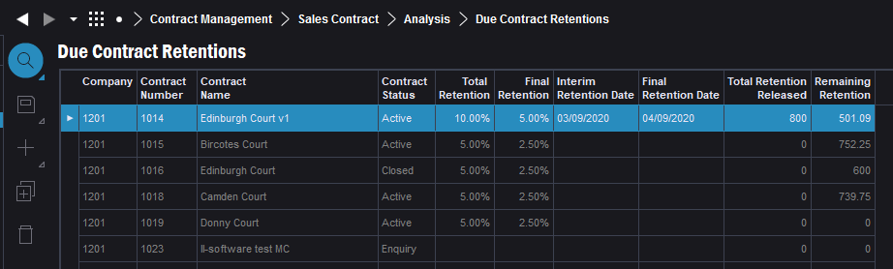

# Lobby Element New Invoice Previews

There are multiple reasons for invoice preview not to get approved. To capture these records, we need a new lobby element which would show all Invoice Previews where status = New and Invoice Scope = Work Order. In addition, records should appear on the lobby element when status has been moved to Reported where > sysdate-1 (yesterday or earlier).

This can be added to the Invoicing Lobby as a tile to show the number of records found. Then user can click on the tile which would open the invoice preview page with search results.

# Lobby Element for Completed Work Orders without Invoice Preview

There can be multiple reasons why invoice preview will not be raised for the specific work orders. To monitor work orders where invoice preview failed to be automated, we need a lobby element which would bring all work orders in status Reported which has sales lines set to invoiceable but does not have Invoice Preview associated to it. In addition, records should appear on the lobby element when status has been moved to Reported where > sysdate-1 (yesterday or earlier).

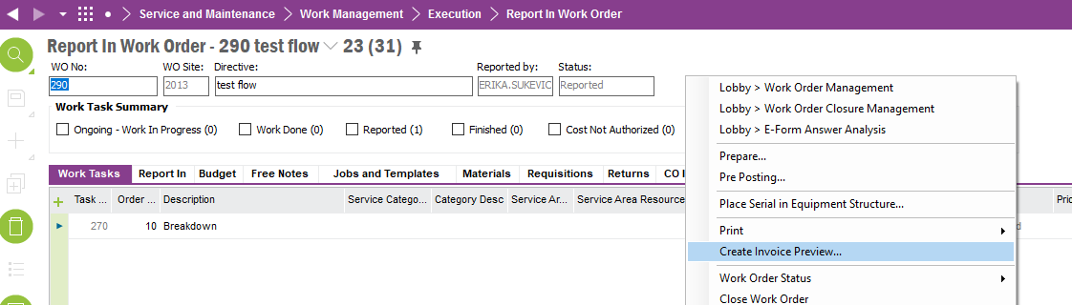

This can be added to the Invoicing Lobby as a tile to show the number of records found. Then user can click on the tile which would open the report in work order page with search results.

# Lobby Element for Chargeable Work

We need a tile style lobby element which would display the number of the work orders where:

* Status of the work order = WorkDone
* No customer order attached to the work order
* Cause selected on the work order task has 0% discount on the associated service package line (see more details on 1.1.5 how to identify the right service package line/value)

OR where

* Status of the work order = Reported
* Status of the customer order attached to the work order <> Closed/Invoiced
* Cause selected on the work order task has 0% discount on the associated service package line (see more details on 1.1.5 how to identify the right service package line/value)

First scenario will allow billing team to correct the cause (if required) before invoicing event will kicks in, the second scenario will allow them to identify incorrect causes once customer order been raised.

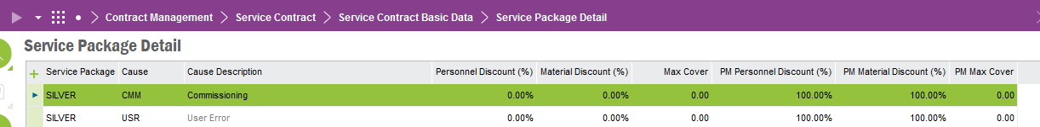

This lobby element needs to be part of the Invoicing Lobby.

# Lobby Element for Non-Chargeable Work

We need a tile style lobby element which would display the number of the work orders where:

* Status of the work order = WorkDone
* No customer order attached to the work order
* Cause selected on the work order task has 100% discount on the associated service package line (see more details on 1.1.5 how to identify the right service package line/value)

OR where

* Status of the work order = Reported
* Status of the customer order attached to the work order <> Closed/Invoiced
* Cause selected on the work order task has 100% discount on the associated service package line (see more details on 1.1.5 how to identify the right service package line/value)

First scenario will allow billing team to correct the cause (if required) before invoicing event will kicks in, the second scenario will allow them to identify incorrect causes once customer order been raised.

This lobby element needs to be part of the new Invoicing Lobby for monitoring invoices.

# Lobby Element - Service Events Log (screen link)

* Require permissions to this screen it is custom LU (see below screenshot).
* Require lobby element tile linking to this screen.

Lobby tile with the title “Service Events Log” that links to the below screen is required on the lobby.

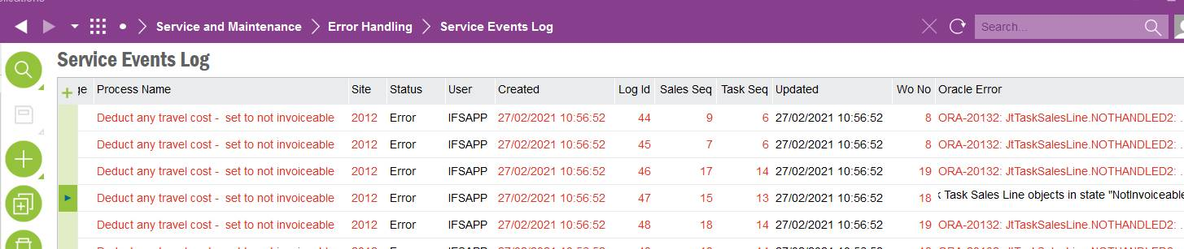

Credit Manager also requires access to this screen as well as the Invoicing Team.

# Technical.

Field Definitions.

<New Field/CLU Definition>

|  |  |  |  |  |  |  |
| --- | --- | --- | --- | --- | --- | --- |
| New DB Object Name | DB Object Item/Field Names | Item Description | Item Data Type | Item Syntax | Calculation Spec, if Derived | LOVs/Enums/Is Mandatory? |
|  |  |  |  |  |  |  |
|  |  |  |  |  |  |  |
|  |  |  |  |  |  |  |
|  |  |  |  |  |  |  |
|  |  |  |  |  |  |  |
|  |  |  |  |  |  |  |
|  |  |  |  |  |  |  |
|  |  |  |  |  |  |  |
|  |  |  |  |  |  |  |
|  |  |  |  |  |  |  |
|  |  |  |  |  |  |  |
|  |  |  |  |  |  |  |

Security

<Define security controls> (Who needs access to this and will it be restricted from any other users etc)

|  |  |
| --- | --- |
| **Role** | **Permissions** |
| Billing Team |  |
| Credit Manager |  |
|  |  |

Companies

Applies to the following companies. All.

|  |  |
| --- | --- |
| **Company** | **Required (Y/N)** |
| 1201 | Y |
| TBC |  |
|  |  |

Data Migration

<Describe any data migration impacts this development may have – i.e additional data to be migrated>

Test Steps

<Steps that needs to be taken to test this change. Please provide expected results> Updated post solution.

|  |  |  |
| --- | --- | --- |
| **No** | **Script\Test Steps** | **Expected Result** |
| 1 |  |  |
| 2 |  |  |
| 3 |  |  |
| 4 |  |  |
| 5 |  |  |
| 6 |  |  |
| 7 |  |  |
| 8 |  |  |
| 9 |  |  |
| 10 |  |  |
| 11 |  |  |
| 12 |  |  |
| 13 |  |  |
| 14 |  |  |
| 15 |  |  |
| 16 |  |  |

Technical Implementation

<Completed by the technical developer - Technical solution, list packages, functions, Custom menus created etc >

# Delivery Notes

1. Grant permissions to **‘Tunstall Invoicing <DATE>’** lobby.

Permission sets: IFS_ALL, FND_QUICK_REPORTS

1. Lobby Parameters:

* Company
* Site
* Contract Type

1. Lobby elements

|  |  |  |
| --- | --- | --- |
| **Element name** | **Custom Function** | **Remarks** |
| Due Response Monitoring Service Contracts |  |  |
| Overdue Invoices Response Monitoring Service Contracts |  |  |
| Due Contract Retentions |  |  |
| New Invoice Previews |  |  |
| Completed Work Orders without Invoice Preview |  |  |
| Chargeable Work | C_EA_Customization_Util_API.Check_Cause_Discount() |  |
| Non-Chargeable Work | C_EA_Customization_Util_API.Check_Cause_Discount() |  |
| Service Events Log |  |  |